Personal Portfolio - Bryce Aird

# Sprint 1 Artefacts

* Storyboard refinement and prioritisation
  + Essential to ascertain user stories and importance
* User stories/ Acceptance Criteria
  + To assure a story has been completed it must fulfil the acceptance criteria
* Estimative Methods/ Team Velocity
  + To ascertain the estimated workload that the group can handle each sprint
* Html/ Bootstrap mock-ups for interface
  + Creation of potential layouts for the website and pages of the website

# Sprint 2 Artefacts

* Peer Review/ Business Letter
  + Review of another group’s project in the form of a letter
* User Acceptance Criteria tests
  + Making certain that stories said to be complete fulfil the acceptance criteria
* Feedback on GUI as client
  + Assuring that the development team is creating the product intended through guidance
* Technical testing of the website
  + To ensure that the website is fully functional

Appendices

# Sprint 1 Storyboard

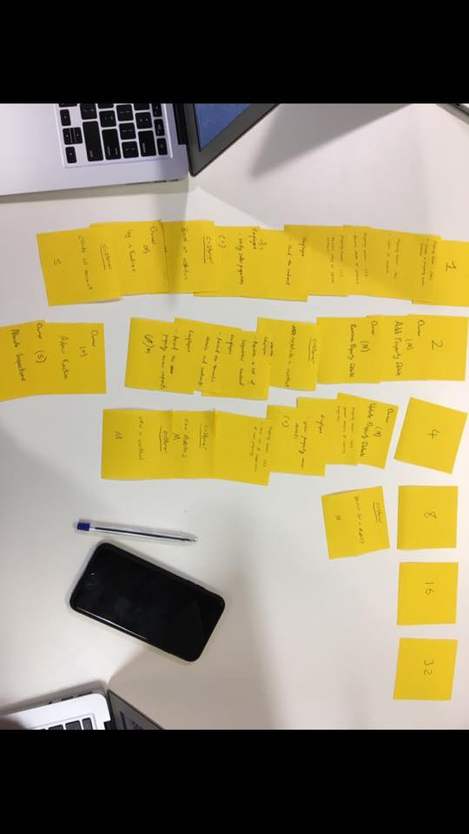

# 17362623_10154493213826589_8313763666234448403_n.jpgSprint 1 Velocity Working